**Khulna University of Engineering and Technology**

**Dept. of Electronics and Communication Engineering**

Course Title: **Antenna Engineering Laboratory**

Course no: ECE-3208

Date of submission: **30-10-2023**

***Submitted by:***

Md. Lavlu Mia

Roll: 1909034

Sumit Das

Roll: 1909044

Hasan Mahmud Shohardyo

Roll: 1909054

***Submitted to:***

Md. Minhajul Islam Arnab

Lecturer

Department of ECE,

KUET

Naymur Rahman

Lecturer

Department of ECE,

KUET

***Project Title:***

**UWB Vivaldi Antenna for Long-Distance Electromagnetic Transmission**

**Design and simulation of an UWB vivaldi antenna for long distance electromagnetic Transmission**

**Motivation:**

The rapid advancement of wireless communication, remote sensing, and navigation technologies has amplified the demand for precise and reliable detection systems. Ultra-wideband (UWB) antennas, known for their high data rates, low power consumption, and capability to operate in cluttered environments, have emerged as a promising solution. Particularly, the Vivaldi antenna, with its wide beam width for transmitting and narrow beam array for receiving, offers a unique set of advantages in terms of positioning and distance coverage. By focusing on a frequency range between 2.5 GHz and 4 GHz, this project aims to leverage the full potential of Vivaldi antennae for long-distance electromagnetic detection. Implementing such an antenna system could significantly enhance the effectiveness of various applications, from emergency response coordination to autonomous vehicle navigation and beyond.

**Objectives:**

1. To design and simulate operation of an UWB Vivaldi antenna in CST software.
2. To analyze the S parameter, impedance bandwidth, radiation pattern, gain, and directivity of the designed antenna.
3. To observe the effect of mesh convergence.
4. To optimize the design to achieve expected output
5. To observe the deviation between the theoretical result and Simulated result.

**Methodology:**

CST Studio Suite® gives the users access to multiple electromagnetic (EM) simulation solvers which use methods such as the finite element method (FEM), the finite integration technique (FIT), and the transmission line matrix method (TLM). We used FEM for this project.

We designed an UWB Vivaldi antenna with the dimensions of 150mm x 150mm x 1.635mm. We operated the antenna in the frequency range of 3GHz to 11GHz. For long range EM transmission we’ve to check the parameters and characteristics between the frequency of 2.5GHz to 4GHz.

We used different layers and materials for this design. The antenna contains four layers:

1. Substrate
2. Shorted layer
3. Ground
4. Port on a microstrip line

**Materials:**

* **Substrate material**: **FR-4 (lossy) material** with dielectric constant of 4.3 and thermal conductivity of 0.3 W/K/m.
* **Shorted layer**: We used different blocks for this layer. But only **Copper (annealed) lossy metal** material was used for the whole layer. This material has an Electric Conductivity of 5.8e+007 S/m, Thermal Conductivity of 401.0 W/K/m, Heat capacity of 0.39 Kj/K/Kg and material density was 8930.0 Kg/m^3.
* **Ground**: We used the same **Copper (annealed) lossy metal** material for the ground with the same specifications used for the shorted layer.
* **Microstrip line**: We used three different blocks for the microstrip line. One of them had **PEC** material and the other two had **Copper lossy** material that has been used for shorted layer and ground.

**Design and other parameters:**

* We designed the antenna using the necessary layers and materials (Figure 1 & 2)
* We set variables for each parameters (table 1) and set different frequencies for simulation purposes.
* 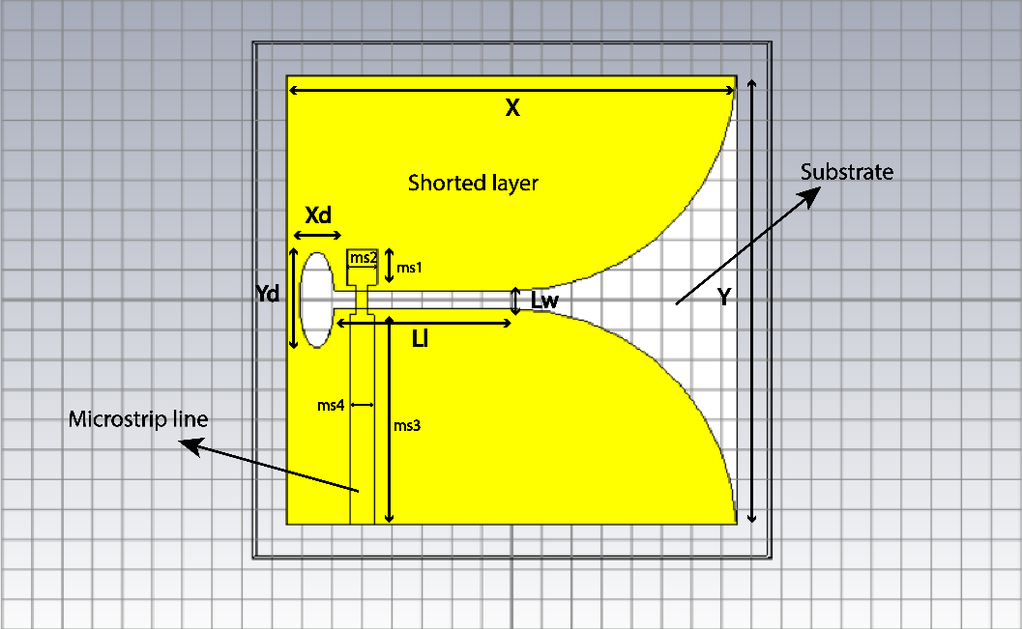We simulated the design in CST and observed & measured the required parameters (s-parameter, impedance bandwidth, resonant frequency, radiation pattern etc.) for different frequencies.

Figure 1: UWB Vivaldi antenna (Front view)

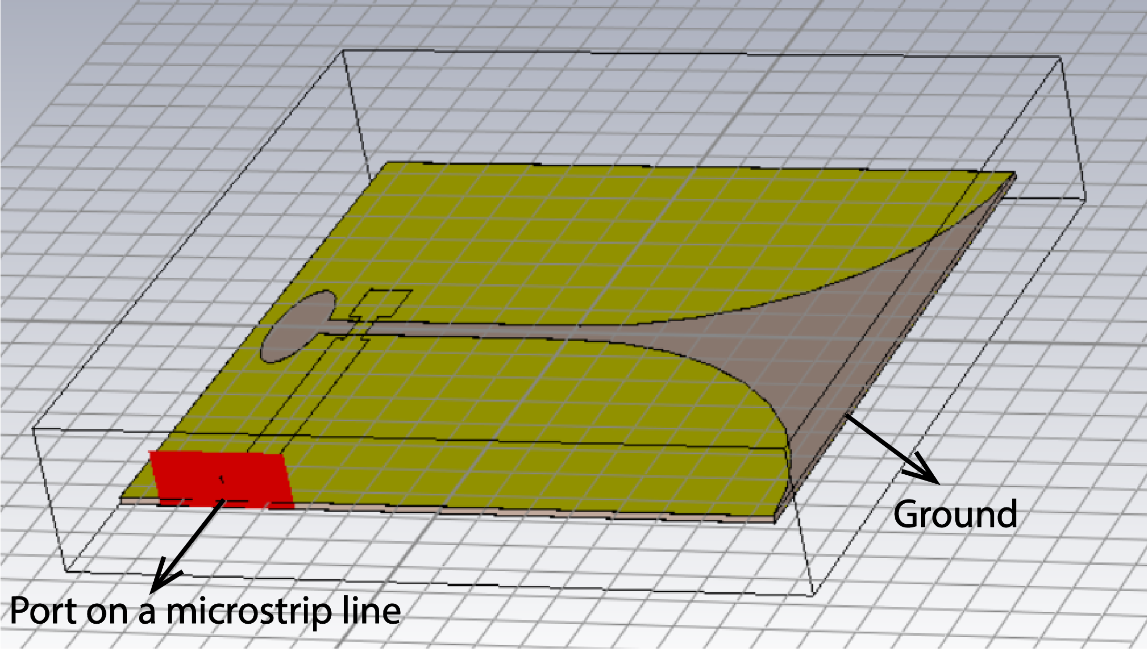Figure 2: UWB Vivaldi antenna (side view)

**Table 1: Design parameters of the UWB Vivaldi antenna:**

|  |  |  |  |
| --- | --- | --- | --- |
| **Parameters** | **Length (mm)** | **Parameters** | **Length (mm)** |
| X | 150 | ms3 | 70 |
| Y | 150 | ms4 | 8 |
| Xd | 6 | ms5 | 12 |
| Yd | 16 | ms6 | 4 |
| Z | 1.635 | Lz | 0.035 |
| ms1 | 12 | Li | 65 |
| ms2 | 10 | Lw | 4 |

* We used some variables in the simulation but only constant value is shown in the table

**Expected Outcomes:**

* We expect to get a good directivity (around 10dB) and gain in the frequency range of 2.5GHz to 4GHz
* Get an approximate s-parameter which is similar to the ideal s-parameter of an UWB Vivaldi antenna (Figure 3)
* The HPBW of the antenna should be less than 70 degrees.
* The VSWR should be less than 2 (Figure 4)
* The return loss should be better than 10 db
* The impedance bandwidth should be close to 1GHz

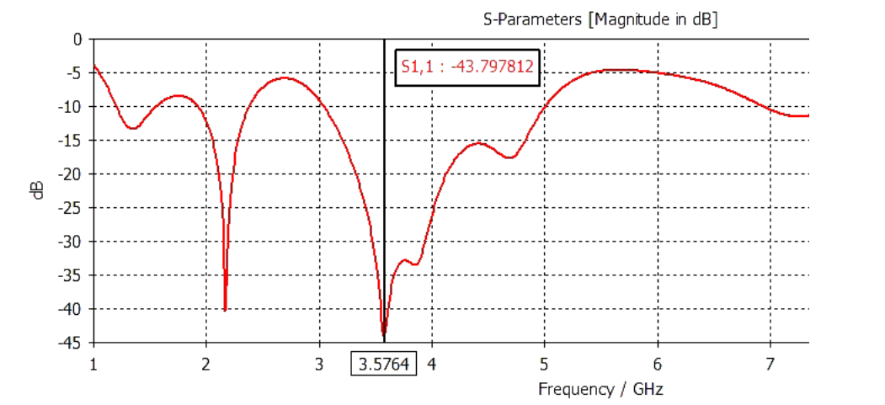

Figure 3: Expected s-parameter curve for an UWB Vivaldi antenna

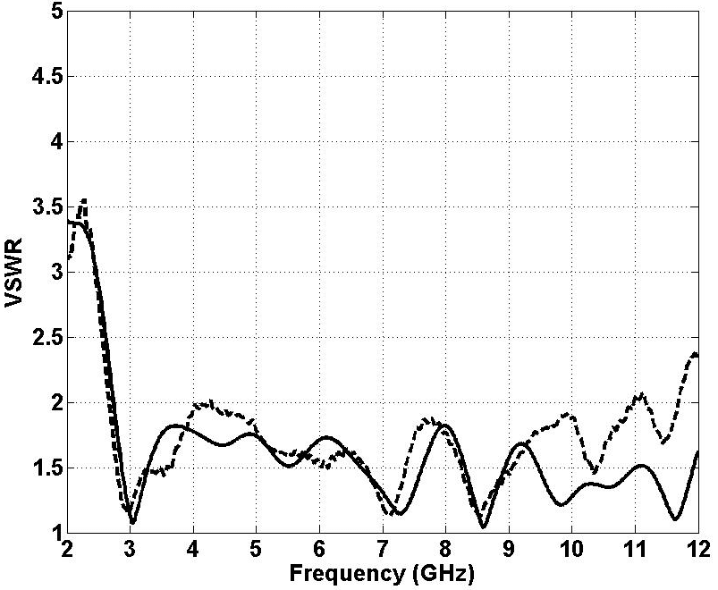

Figure 4: Expected VSWR curve for an UWB Vivaldi antenna